Photostabilization of Poly(vinyl chloride) (PVC)

The Degradation Problem
PVC, a widely used plastic, suffers from degradation when exposed to ultraviolet (UV) light, a common occurrence during its processing. This degradation involves:
1.Dehydrochlorination: The loss of hydrogen chloride (HCl) from the PVC backbone, leading to the formation of double bonds.

2.Auto-oxidation: Reaction with oxygen, leading to chain scission and crosslinking.

3.Mechano-chemical chain scission: Breaking of polymer chains due to mechanical stress.

4.Crosslinking: Formation of bonds between polymer chains.

5.Condensation reactions: Reactions between functional groups on polymer chains.
This degradation results in discoloration, embrittlement, and loss of mechanical properties.
Stabilizers to the Rescue
Stabilizers are added to PVC to prevent or slow down its degradation. There are two main types of stabilizers:
1.Primary stabilizers: These react with allylic chlorines (chlorine atoms adjacent to a double bond) to prevent the dehydrochlorination reaction. They also act as Lewis acids, forming complexes with chlorine atoms and preventing them from participating in degradation reactions.

2,Secondary stabilizers: These scavenge the hydrogen chloride (HCl) produced during degradation. HCl acts as a catalyst for further degradation, so removing it helps to slow down the process.
Combined Approach for Optimal Stability
A combination of primary and secondary stabilizers is often used to achieve the best possible stabilization of PVC. Primary stabilizers ensure good early color and initial stability, while secondary stabilizers provide long-term stability by preventing the autocatalytic effect of HCl.
There is substantial ongoing research in the field of photodegradation of polymeric systems, indicated by numerous scientific publications.
This interest is due to the need for materials with better outdoor durability.
Susceptibility to Photodegradation:
All commercial organic polymers, including PVC, degrade when exposed to sunlight and air.
Polymers exhibit a wide range of photo-oxidative susceptibilities.
Role of UV Light:
Near ultraviolet (UV) wavelengths are primarily responsible for initiating photodegradation.
UV light absorption leads to bond-breaking reactions, resulting in the loss of physical properties and discoloration.
Impact on Mechanical Properties:
1.Photodegradation causes significant changes in the mechanical properties of PVC.
2.These changes can include a decrease or increase in average molecular weight.
3.Decrease in molecular weight is due to chain scission (breaking of polymer chains).
4.Increase in molecular weight can result from crosslinking (joining of polymer chains).

Mechanism of PVC Photodegradation
Photooxidative degradation refers to the degradation of PVC when it is exposed to sunlight and oxygen, involving both photolysis (breaking of chemical bonds by photons) and oxidation (reaction with oxygen). When PVC is exposed to UV light in the presence of oxygen (O2), the primary photochemical processes lead to the formation of excited singlet polyenes. These excited states can follow various pathways and PVC undergoes a series of reactions:

- Formation of Excited States: UV light excites polyenes within the PVC structure.

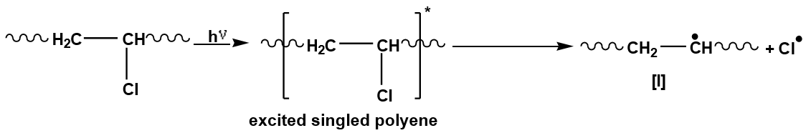

- Allylic C-Cl Bond Cleavage: The excited polyenes break apart, releasing chlorine radicals (Cl.) and polyene radicals (I).

- Reaction with Oxygen: Polyene radicals (I) react with oxygen (O2) to form peroxy radicals (II).

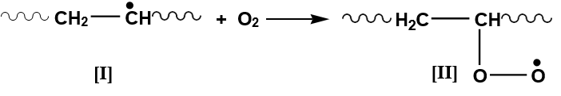

- Chain Dehydrochlorination: Peroxy radical [II] can react with (CH2) and (CH-Cl) groups in PVC. Reaction with (CH2) forms radical [III], contributing to chain-dehydrochlorination of PVC.
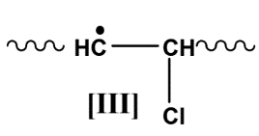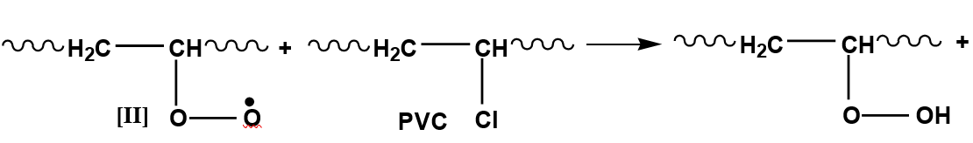

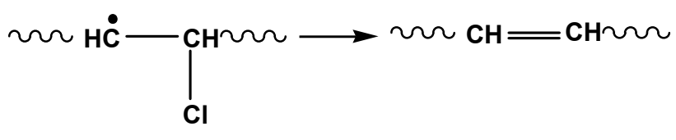
Reaction with (CH-Cl) forms radical [IV], which reacts with O2 to give γ-chloroalkyl peroxy radical [V].
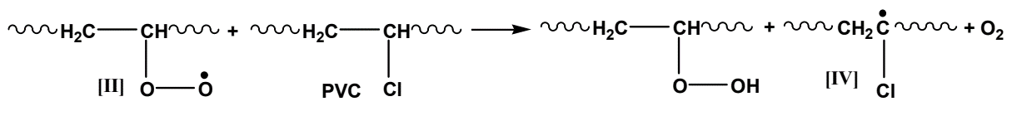
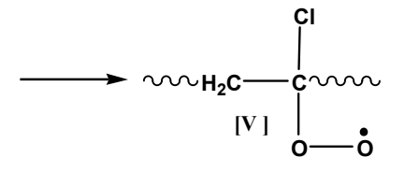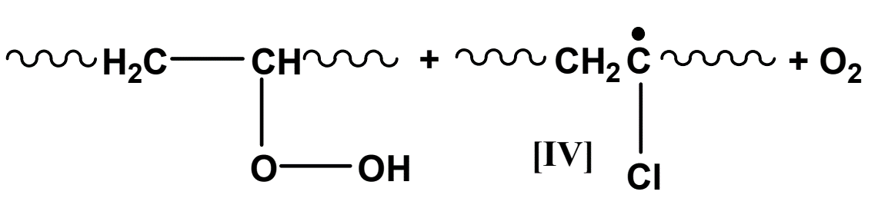

- Oxidation Products: Major oxidation products come from reactions of γ-chloroalkyl peroxy radical [V]. Hydrogen abstraction from PVC forms hydroperoxide groups.

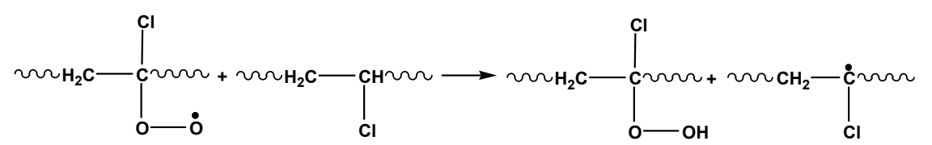
Bimolecular interactions lead to the formation of a peroxide bridge (termination reaction).

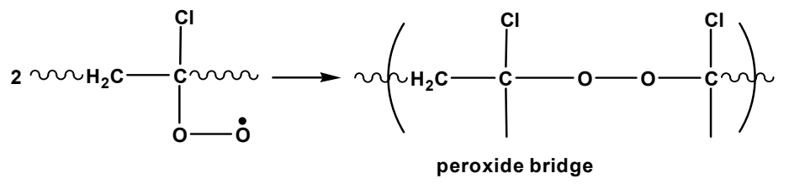

- Alkoxy Radicals: Alkoxy radicals [VI] usually abstract hydrogen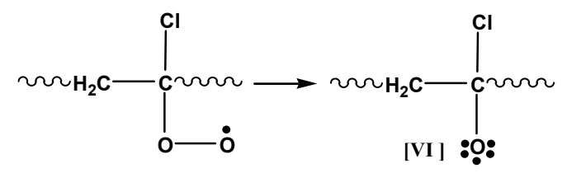
α-chloroalcohol decomposes into ketones. Tertiary alkoxy radicals stabilize by β-scission, forming ketones or polyenes.
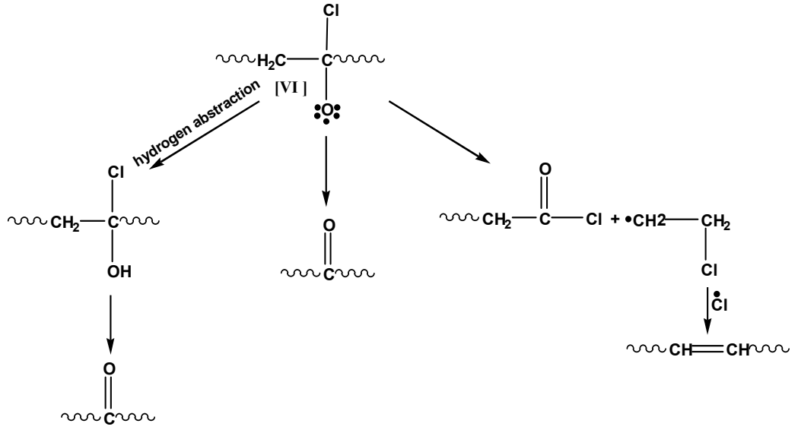

Role of Oxygen
Oxygen plays a complex role in the photodegradation of PVC:
- Decreases activation energy.
- Accelerates dehydrochlorination.
- Causes bleaching by attacking polyene structures.
- Promotes chain scission and crosslinking.
The rate of photo-oxidation decreases with increasing film thickness due to reduced oxygen diffusion.
The overall mechanism now suggested for the photooxidation of PVC to account for the main primary products can be summarized by the reaction shown in below figure.

Kinetics of Degradation
Polyvinyl chloride (PVC) undergoes photo-oxidation, a process involving free radical chain reactions, which leads to its degradation. Here’s a detailed explanation of the kinetics of this process:
Primary Reaction:
$P•+ O_{2}→PO_{2}•---\left(1\right)$
* P• : Polymer radical
* $O_{2}$ : Oxygen
* $PO_{2}$• : Peroxy radical
Rate-Determining Step:
$PO_{2}•+PH\underset{→}{k_{d}}POOH+P•---\left(2\right)$
* PH: Polymer molecule
* $k_{d}$: Rate constant for the reaction
* POOH: Hydroperoxide
Reaction (3-2) is the rate-determining step of the photodegradation process. The hydroperoxide (POOH) molecules produced subsequently undergo photolysis:
Photolysis of Hydroperoxide:
$POOH\underset{→}{hν}PO•+•OH---\left(3\right)$
* hν: Photon (light energy)
* PO•: Alkoxy radical
* •OH: Hydroxyl radical
The alkoxy radical (PO•) can then react further:
$PO•+PH\underset{→}{k_{i}}POH+•P---\left(4\right)$
* $k_{i}$: Rate constant for this reaction
Additionally, the alkoxy radical can undergo a Norrish type I reaction:
$PO•→P-CH=O---\left(5\right)$
Norrish Type I Photolysis:
$P^{'}COOP\underset{→}{hν}P^{'}CO_{2}+•P^{''}---\left(6\right)$ $P^{'}CO_{2}•+PH\underset{→}{k_{if}}P•+Hydroperoxide---\left(7\right)$
Termination reactions likely occur via the disproportionation of alkylperoxy radicals:
$2PO_{2}• \underset{→}{k_{t}}Stableproduct---\left(8\right)$
* $k_{t}$: Rate constant for termination
Rate Equations and Steady-State Conditions

Rate of Initiation:
$R_{i}=k_{if}\left(I_{CO}\right)\left[PH\right]----\left(i\right)$
* $I_{CO}$: Carbonyl index
* $k_{if}$: Rate constant for initiation involving carbonyl compounds
Rate of Degradation:
$R_{d}=k_{d}\left[PO•\right]\left[PH\right]----\left(ii\right)$
Rate of Termination:
$R_{t}=k_{t}{\left[PO_{2}•\right]}^{2}----\left(iii\right)$
Under steady-state conditions, the rate of termination equals the rate of initiation:
$k_{t}{\left[PO_{2}•\right]}^{2}=k_{if}\left(I_{CO}\right)\left[PH\right]$
Solving for PO2•:
$\left[PO_{2}•\right]={\left(\frac{k_{if}}{k_{t}}\left(I_{CO}\right)\left[PH\right]\right)}^{\frac{1}{2}}----\left(iv\right)$
Substituting equation (iv) into equation (ii):
$R_{d}=k_{d}{\left(\frac{k_{if}}{k_{t}}\right)}^{\frac{1}{2}}{\left(I_{CO}\right)}^{\frac{1}{2}}{\left[PH\right]}^{\frac{3}{2}}$
This simplifies to:
$R_{d}=k_{c}{\left(I_{CO}\right)}^{\frac{1}{2}}$
Where:
$k_{c}=k_{d}{\left(\frac{k_{if}}{k_{t}}\right)}^{\frac{1}{2}}{\left[PH\right]}^{\frac{3}{2}}$

